Task8:

Q: Given two strings needle and haystack, return the index of the first occurrence of needle in haystack or "-1" needle is not part of haystack

Analysis:

* Create function task8 with two parameters.
* Check the needle value(string) is not empty, if it’s empty return 0.
* In the for loop compare the haystack string to check each possible substring.
* Next, For loop compares the substring characters with the characters in needle value to check for a match.
* If the match is found, the function returns the index position of the matching substring otherwise, it’s returns -1.

Flowchart:

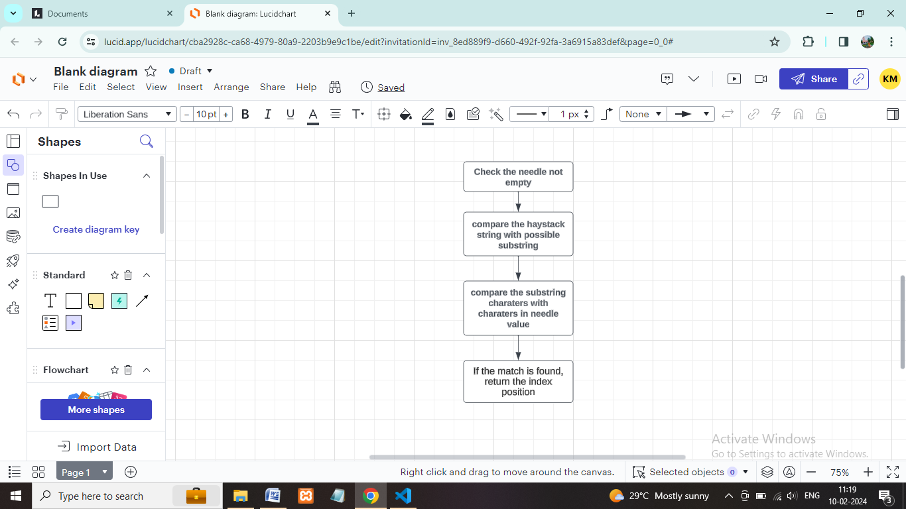

Coding:

function task8(needle, haystack)

{

if (needle === "")

{

return 0;

}

for (let i = 0; i <= haystack.length - needle.length; i++)

{

let result = true;

for (let j = 0; j < needle.length; j++)

{

if (haystack[i + j] !== needle[j])

{

result = false;

break;

}

}

if (result) {

return i;

}

}

return -1;

}

// const haystack = "leetcode";

// const needle = "leeto";

const haystack = "sadbutsad";

const needle = "but";

const index = task8(needle, haystack);

if (index !== -1)

{

console.log(`The needle string is found at index ${index}`);

} else {

console.log(`The needle string is not found in the haystack`);

}

Output:

